**Simulation of solar system  
Daniel Sanaee**

Contents

1. Introduction 2

1.1. Background 2

1.2. In this report 2

1.3. Purpose and problem question 2

2. Physics and Model 3

2.1. Newton’s law of gravity 3

2.2. Newton’s second law of motion 3

2.3. Hamiltonian mechanics 3

2.3.1. Hamiltonian mechanics 3

2.3.2. Integrators 4

2.4. Clarifications on the model 5

2.4.1. On perfect periodicity 5

2.4.2. Elliptical versus circular orbits 6

2.4.3. Other disclaimers 6

3. Method 7

3.1. Simulation setup 7

4. Results 7

4.1. Visual simulation of solar system 7

4.1.1. The sun with all planets 7

4.1.2. Injecting an asteroid 8

4.2. Injecting asteroid near Earth 10

4.2.1. Visualising near collision 10

4.3. Injecting massive asteroids into the solar system 11

4.3.1. A planet-sized asteroid near Earth 11

4.3.2. A star like asteroid near Earth 12

4.4. Energy conservation 13

4.5. Asteroid perturbance to Earth’s orbit 16

5. Discussion 19

5.2. Quality of integrators 19

5.3. On chaotic motion 20

6. References 20

# Introduction

## Background

The solar system was formed 4.568 billion years ago from remnants of an interstellar molecular cloud. The sun constitutes 99.86% [1] of the total mass of the system. Planets and other celestial bodies are as a result bound by the attracting gravitational force exerted from the sun. With a mass roughly 333 000 times the mass of the Earth, the sun’s gravitational presence is ubiquitous for all objects in the solar system. In addition to the eight planets and their respective moons, the solar system is bustling with asteroids, comets and meteors.

Asteroids can be massive and travel with high velocities in relation to Earth. Thus, the kinetic energy transfer in the event of a direct impact with an incoming interstellar asteroid could certainly destroy Earth and wipe out humanity. Fortunately, the risk of such event is minimised due to planetary sizes being miniscule in comparison to the vastness of space. However, the dangers to Earth from asteroids are not limited to direct collisions. The mass of an asteroid passing nearby Earth establishes a mutual attracting force which can result in significant disturbances of Earth’s orbital trajectory and in theory even eject Earth from the solar system.

## In this report

This report is on a python script simulating the solar system, including the eight planets. The planetary trajectories will be simulated and analysed using the finite differential method with the symplectic Euler-Cromer and Verlet integrators. Other non-symplectic integrators, such as the Runge-Kutta integration scheme, will not be implemented because symplectic integrators are crucial for long energy-preserving simulation such as this. In this report the accuracy of the Euler-Cromer and Verlet integrators in a conservative energy system will be discussed.

Additionally, an asteroid of variable size, speed and coordinates is injected into the system, close to Earth. The effect caused by the asteroid will be analysed and discussed. The effect on the asteroid caused by Earth will also be simulated and looked at.

## Purpose and problem question

This report has two purposes. The first is to better understand the symplectic integrators and their usefulness to system of conservative forces. The second purpose of this simulation is to gain better understanding of threats to Earth from near passing asteroids.

# Physics and Model

## Newton’s law of gravity

In classical physics, any mass generates an attracting gravitational force first described by Isaac Newton. Newton’s law of universal gravitation states that every mass element attracts every other mass element with a force proportional to the product of the mass elements and inversely proportional to the squared distance between them. The equation for this attracting force is expressed as the following:

With the units G is experimentally found to be roughly .

## Newton’s second law of motion

Summing the attracting force from all astronomical objects on one particular object yields a resulting force. Newtons second law of motion states that the resulting force on a mass element is the product of the mass times its acceleration, given no change of mass. Expressed as an equation in this context results in the following:

In this simulation the mass elements are the planets, asteroids or the sun. For the most part the acceleration will be pointed toward the sun since, as mentioned, the sun constitutes the vast majority of the mass in the system.

## Hamiltonian mechanics

### Hamiltonian mechanics

Hamiltonian mechanics are the rigorous formulation of classical mechanics. Hamiltonian mechanics consists of the Hamilton’s canonical equations which uniquely define the time evolution of an arbitrary system [2]. The Hamiltonian equations are a system of first order differential equations strictly implied by Lagrange’s equations of motion, see [3] for proof. Hamilton’s equations, with , in its most general form are expressed as follows:

In this simulation, using , Hamilton’s equations yield the form:

Using these equations, assuming T constant, we once again receive the expression for the force and acceleration formulated in section 2.2.

### 2.3.2. Integrators

In this Hamiltonian simulation two symplectic integrator schemes are used — Euler-Cromer integrator and Verlet integrator. Symplectic integrators conserve energy better than other integrators since the Jacobian under the mapping of an area element from the domain to the new area element is one. This means the vertices of any shape in the domain won’t be stretched or contracted in such way that the area within changes, which is akin to the Hamiltonian (energy) of that shape, and consequently the entire system, changing.

These integrators have been chosen for their symplectic properties. The simulation runs for many timesteps and using a non symplectic integrator would result in inaccurate and unrealistic results. Furthermore, the Euler-Cromer integration and the Verlet integration provide ease in implementation as they are straight forward and easy to understand.

The Euler-Cromer integration scheme is implemented as follows:

The Verlet integration scheme is implemented as follows:

## Clarifications on the model

### On perfect periodicity

Newton’s law of gravity in union with Newton’s second law of motion allows for perfect periodicity under 3 strict constrictions. Assuming the solar system perfectly isolated from the rest of space, that only the sun exerts pull on planets and space is without friction, then Newton’s law of universal gravitation suggests planetary orbits results in perfect elliptical trajectories.

However, in this simulation the model used allows for two differences that independently break perfect periodicity: First, the forces between planets are in fact considered which means interplanetary perturbances generally denies perfectly periodic orbits. Second, finite timesteps are used to discretely calculate new accelerations. The step size corresponds to an error which in turn depends on which integrator is used.

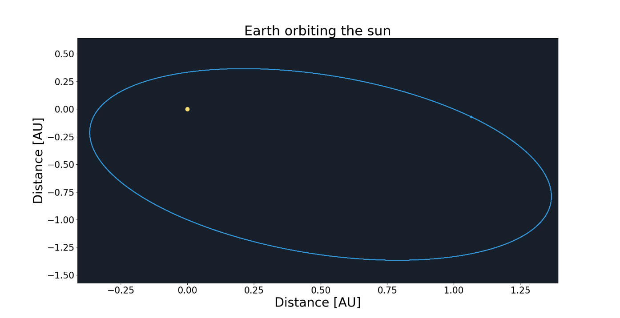

Figure 2.3.1 - 1: Earth orbiting the sun 20 times. Ostensibly perfectly periodic. This figure is generated using Euler-Cromer integrator with step-size of 1 hour.

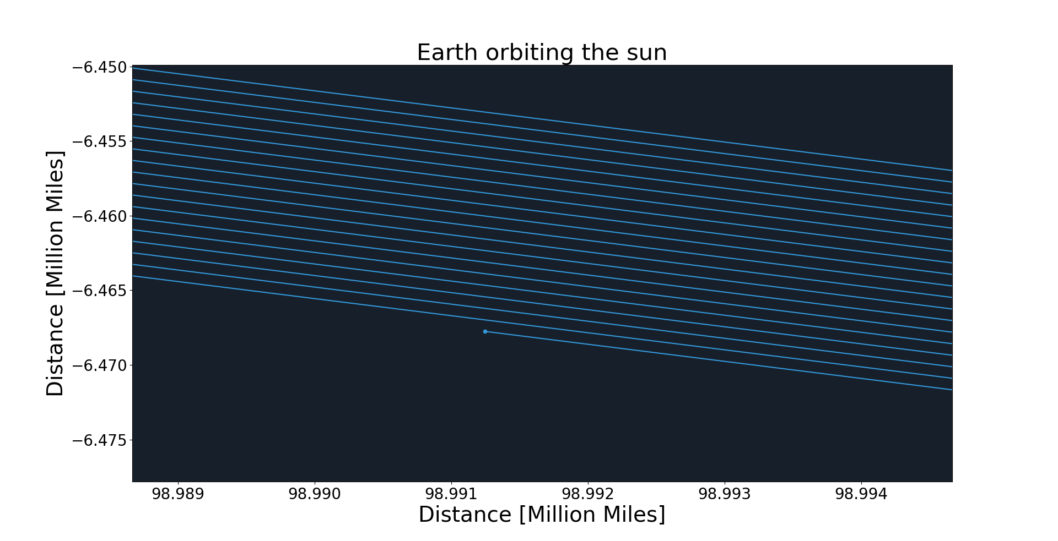

Figure 2.3.1 - 2: Earth orbiting the sun 20 times. Upon closer look the Earth is pulled inwards due to simulation error. In this case the error is entirely attributed to the integrator and not Earths pull on the sun or interference from other celestial bodies. This figure is generated using Euler-Cromer integrator with step-size of 1 hour.

### Elliptical versus circular orbits

In this simulation, for aesthetic reasons only and without loss of generality, the initial planetary spatial coordinates and velocities of the simulation are set to generate perfect circular orbits. This is achieved by assuming the initial velocity is purely orthogonal to the vector connecting the bodies. Planetary orbits are not circular in real life but are often simplified to such forms, perhaps for greater symmetrical satisfaction if nothing else.

### Other disclaimers

No planets, including Earth, are simulated with their moons. Additionally, a more accurate simulation considers the curvature of spacetime to better predict Mercury’s orbit, however, this simulation does not consider general relativity. To further mitigate errors in Mercury’s orbit, adaptive step size integrators would be useful. This report does not use adaptive step size integrators, but their use is discussed in the final chapter. Finally, Mercury has the highest eccentricity and therefore the least circular orbit of any planet in the solar system. These three combined factors make this simulation uncertain and unfit for use in predicting Mercury’s orbit.

As this report is about future threats to humanity, asteroids with masses beyond those of the most massive within our solar system will be considered, despite seeming unrealistic. In this report the word “close” will be used often. In all cases, “close”, means anything less than 0.01 astronomical units. This is enough for massive asteroids to have significant impact, as discussed below.

# Method

## Simulation setup

The python code used in this simulation is an object oriented single threaded script. The simulation consists of three imported packages — “Matplotlib”, “Numpy” and “Math” packages. The simulation generates an object representing the solar system and creates multiple objects within this solar system object representing the astronomical bodies with relevant data as attributes.

The forces, coordinates, velocities, and ultimately energies of the planets are calculated by iterating over all astronomical bodies within the solar system class. The acceleration on each body is calculated using the expression derived in section 2.2 and the information is updated using two different symplectic integrator schemes.

# Results

## Visual simulation of solar system

In this section a number of figures displaying the results of the simulation is visualised. All results will be derived using the Euler-Cromer integration for using the Verlet integrator yields, to the eye, undistinguishable results. Verlet integration will be used when comparing the two integrators in section 4.4. Note that the sizes of the planets are greatly exaggerated for visual purposes.

### The sun with all planets

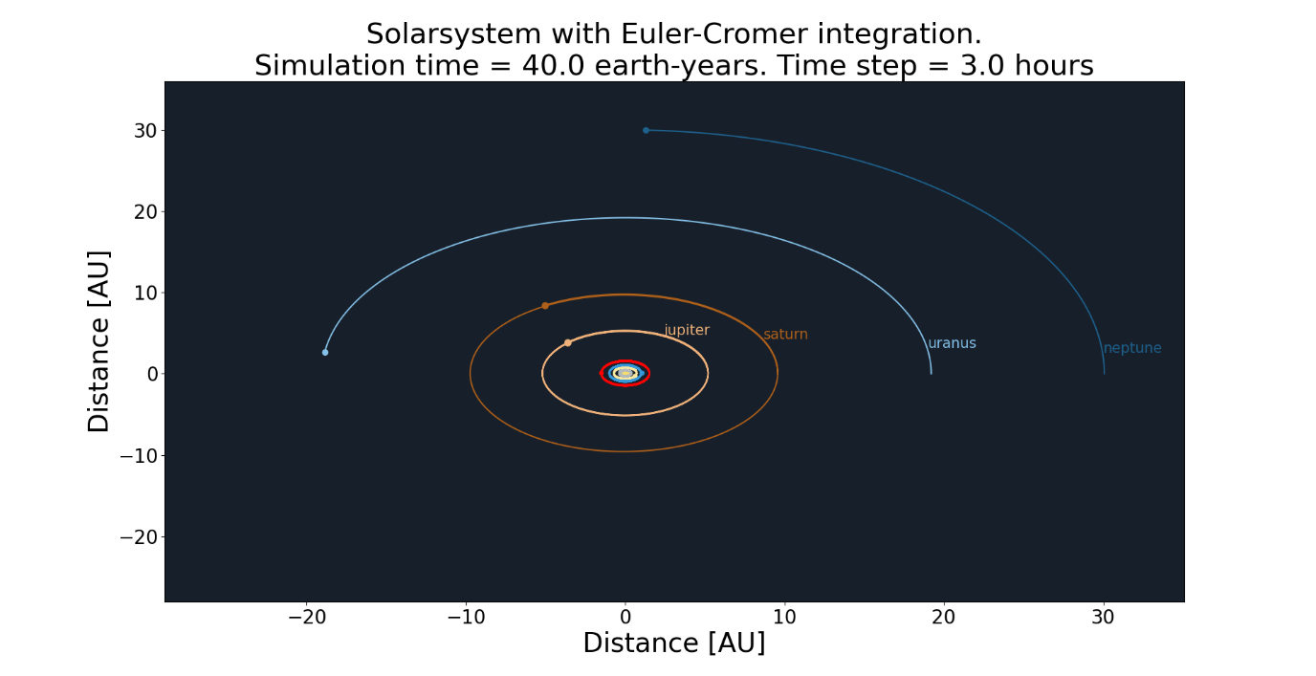

Figure 4.1.1 - 1: Simulation of the solar system using Euler-Cromer integration. Jupiter, Saturn, Uranus and Neptune labelled.

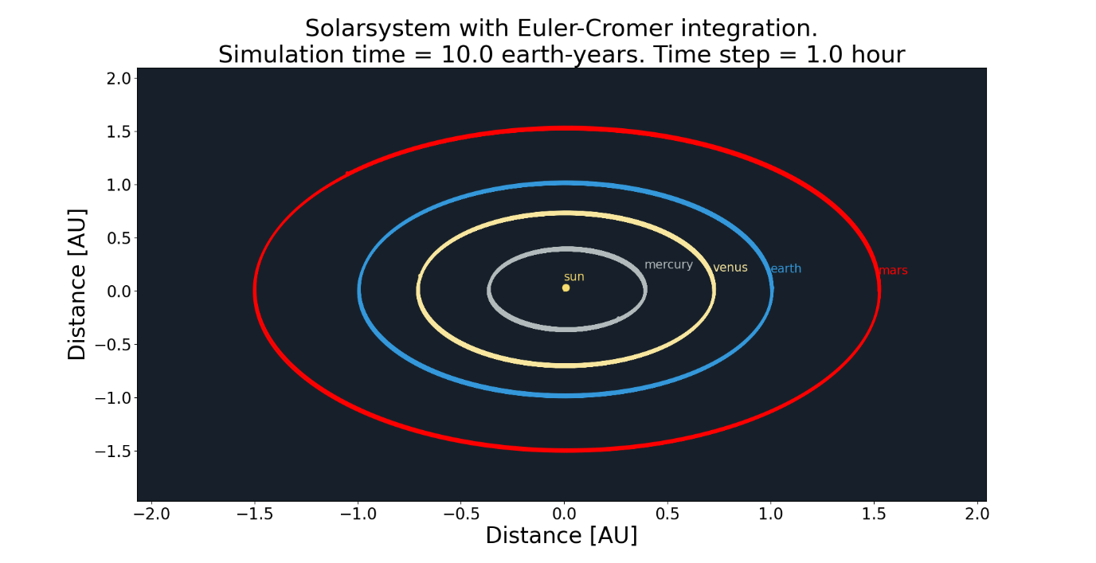

Figure 4.1.1 - 2: Simulation of the solar system using Euler-Cromer integration. Sun, Mercury, Venus, Earth and Mars labelled.

### Injecting an asteroid

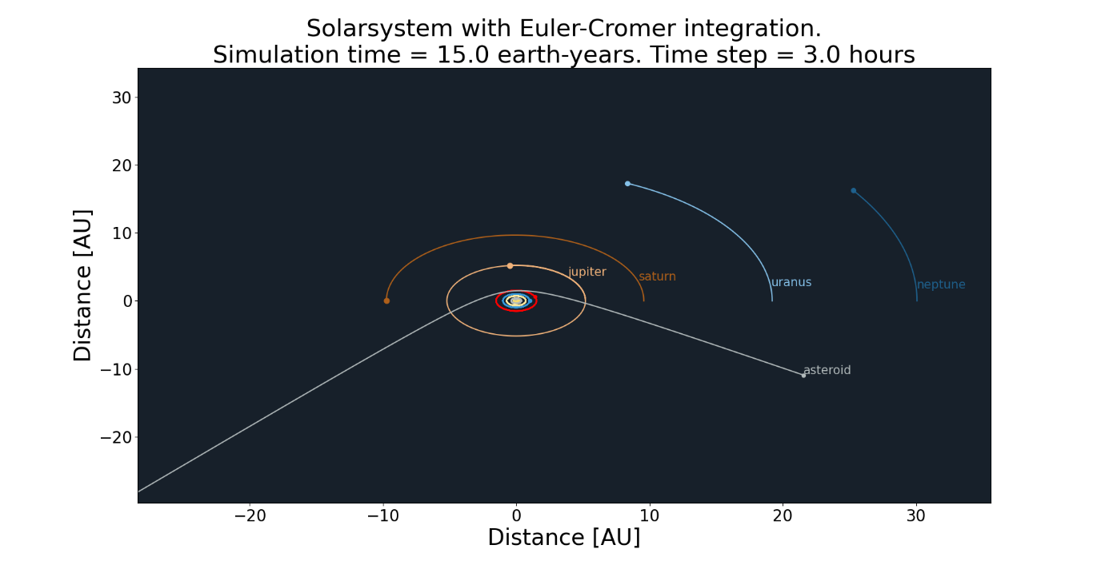Below are two figures visualising an asteroid entering the solar system, changing trajectory and being flung out again. Figure 4.1.2-1 and 4.1.2-2 show the same simulation but for different times. The second figure shows the asteroid barely entering Mars’ orbit.

Figure 4.1.2 – 1: Trajectory of asteroid from outer space deflected by the gravitational pull of the sun. Asteroid mass of 1% of Earths and initial speed of 63% of Earths.

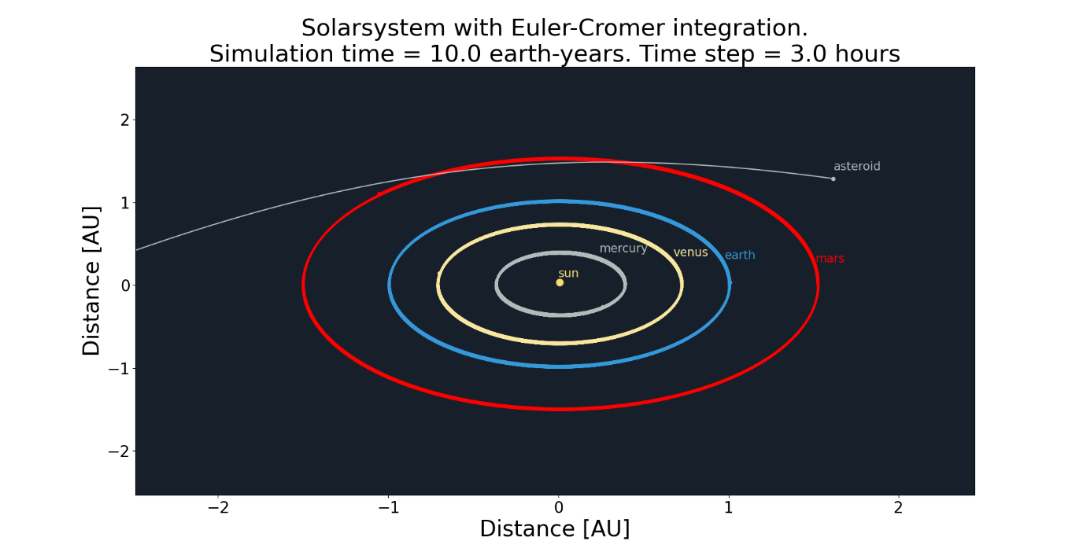*Figure 4.1.2 – 2: Trajectory of asteroid from outer space deflected by the gravitational pull of the sun. Asteroid mass of 1% of Earths and initial speed of 63% of Earths.*

## Injecting asteroid near Earth

### Visualising near collision

In the following figures an asteroid trajectory close to Earth is visualised. In this the time steps will be shorter to mitigate the effects of great forces as objects become close.

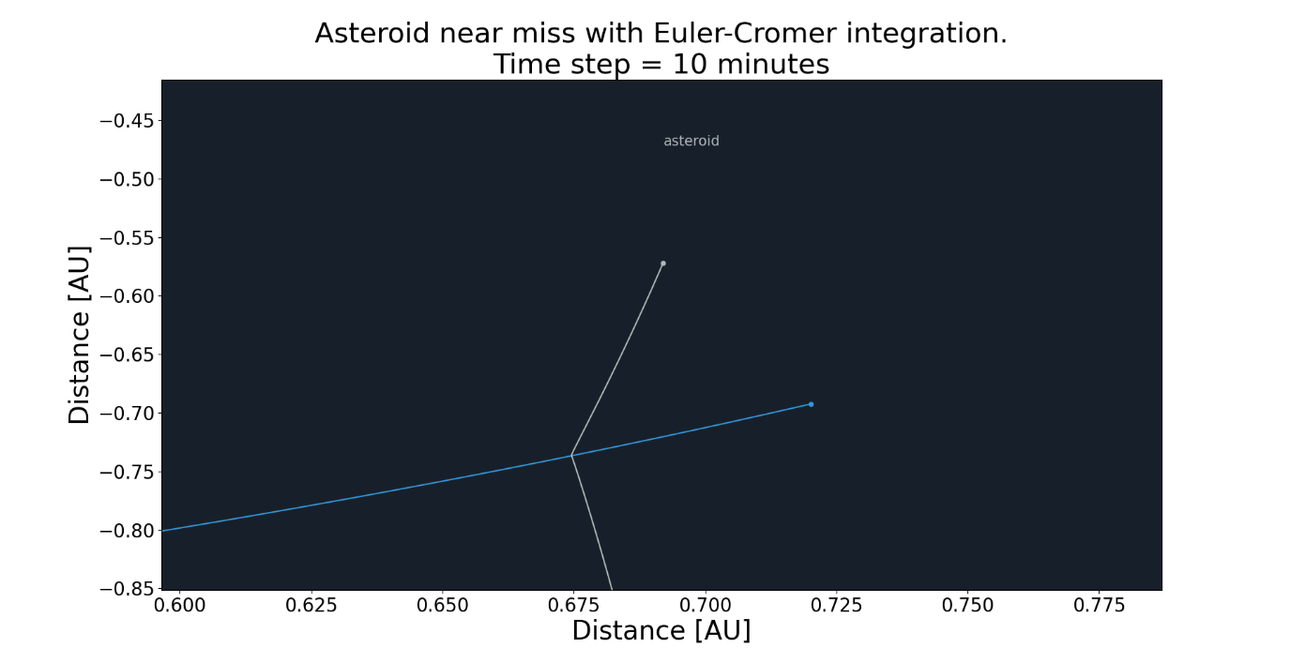

Figure 4.2.1 – 1: Trajectory of asteroid from outer space deflected by the gravitational pull of the Earth. Asteroid mass of 1% of Earths and initial speed twice that of Earths.

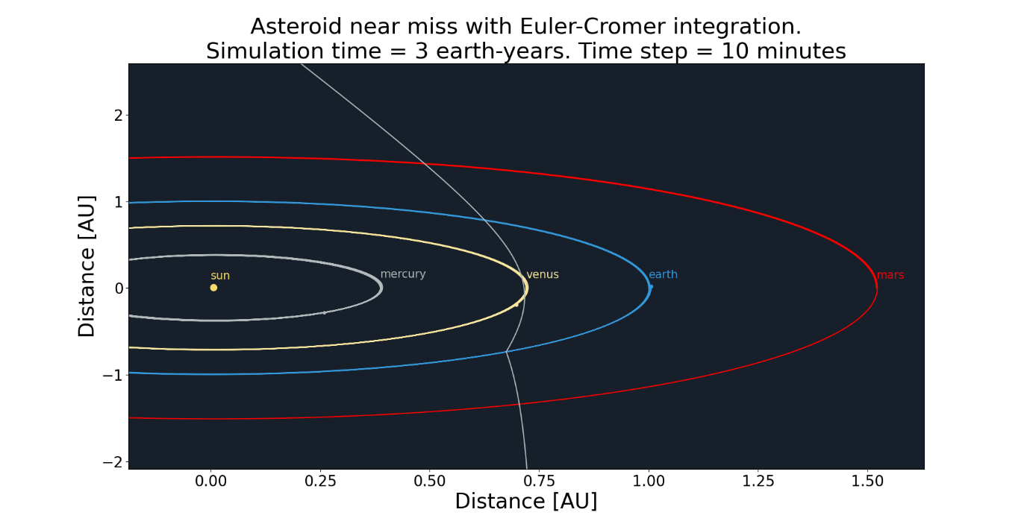

Figure 4.2.1 – 2: Trajectory of asteroid from outer space deflected by the gravitational pull of the Earth. Asteroid mass of 1% of Earths and initial speed twice that of Earths.

## Injecting massive asteroids into the solar system

### A planet-sized asteroid near Earth

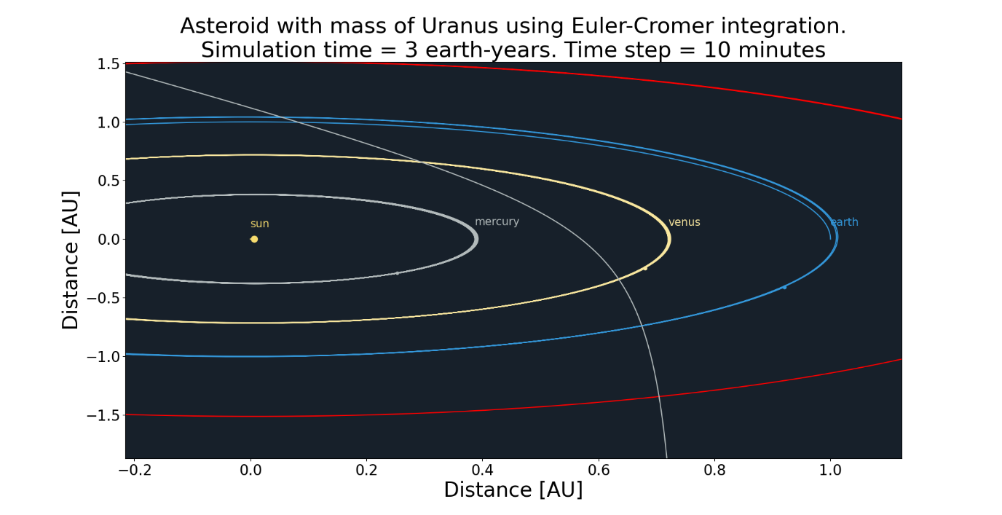In this section the injected asteroid will take the mass of Uranus and Jupiter which translates to roughly 15 and 318 earth masses.

*Figure 4.3.1 – 1: Trajectory of asteroid with mass of Uranus and initial speed twice that of Earths from outer space. Perturbance of Earth’ orbital trajectory can be seen.*

*Figure 4.3.1 – 2: Trajectory of asteroid with mass of Jupiter and initial speed twice that of Earths from outer space. The sun can be seen attracted to the asteroids gravitational pull.*

### A star like asteroid near Earth

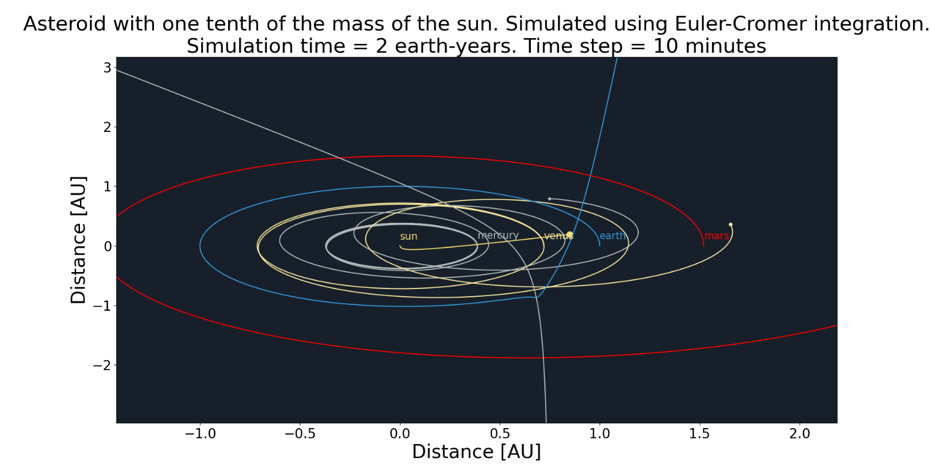In this section the injected asteroid will take the mass of 33 000 and 333 000 masses of earth. This translates to a mass roughly one tenth respectively one whole sun.

*Figure 4.3.2 – 1: Trajectory of asteroid initial speed twice that of Earths from outer space. The solar system is thrown off balance and the Earth is ejected from orbit and the solar system.*

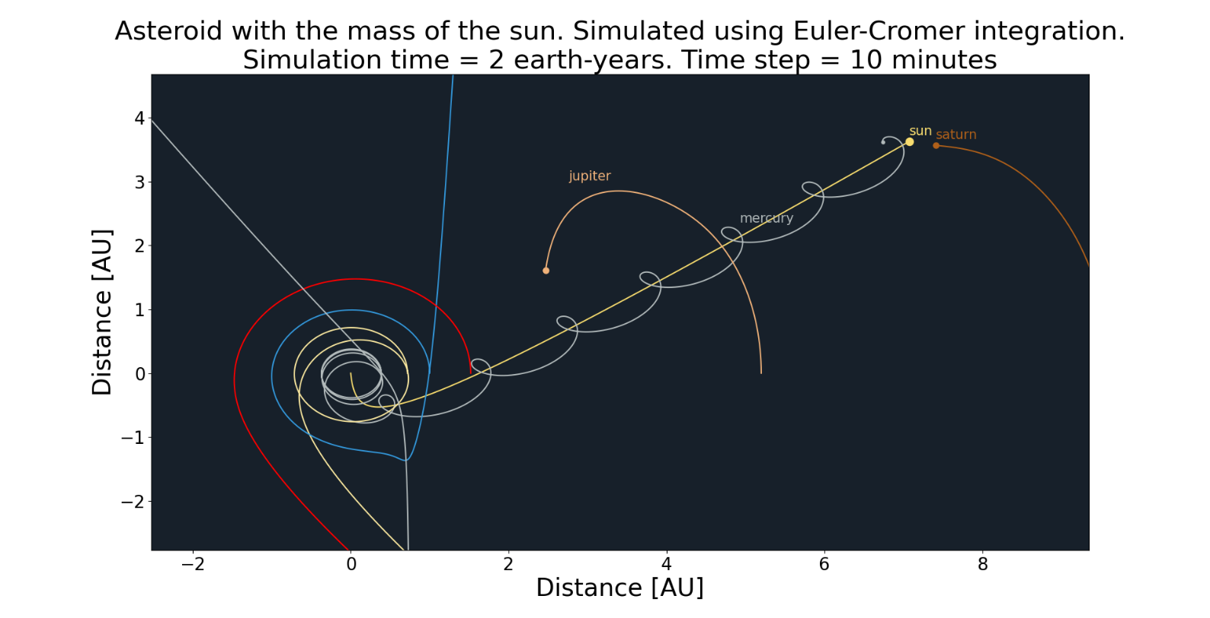*Figure 4.3.2 – 2: Trajectory of asteroid initial speed twice that of Earths from outer space. The solar system is thrown off balance and the Earth is ejected from orbit and the solar system. Mercury follows the ejected sun because of its great pulling force.*

## Energy conservation

In this chapter energy conservation of the earth will be analysed. To do this, both Euler-Cromer integration and Verlet integration will be considered. No asteroid will be present to disturb the trajectory of the earth and other planets do not exert force on the earth. This is done to avoid transferring energy from the Earth to other astronomical bodies which allows for more precise analysing of the integrators. Using these constraints, the potential and kinetic energy should ideally be perfectly periodic. Below are graphs illustrating the effectiveness of Euler-Cromer integration and Verlet integration.

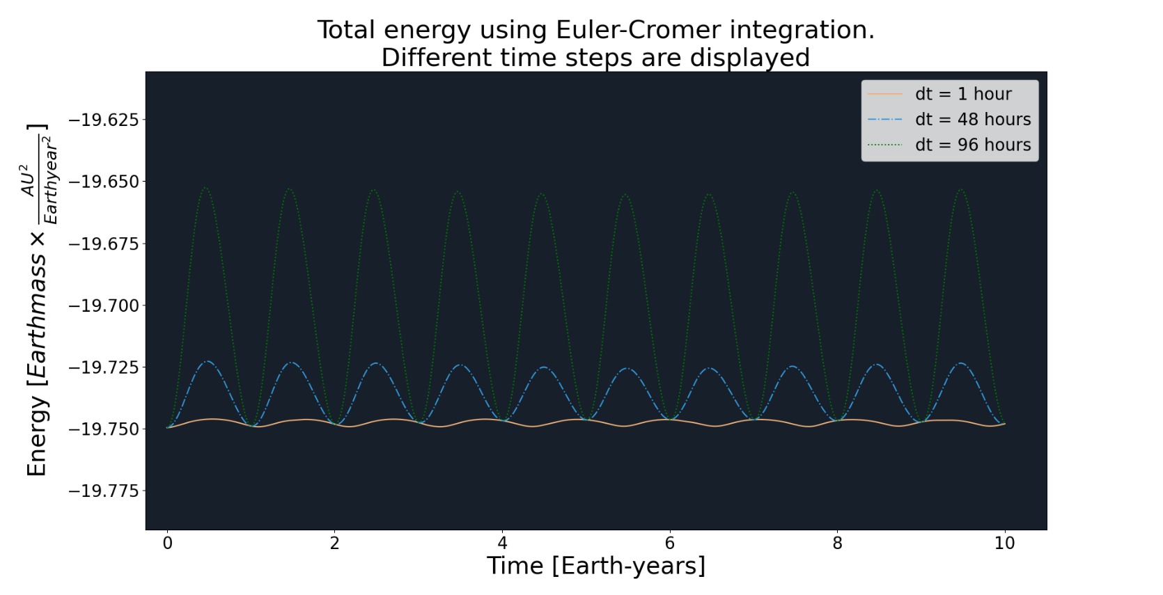

*Figure 4.4 – 1: Total energy of Earth using Euler-Cromer integration.*

*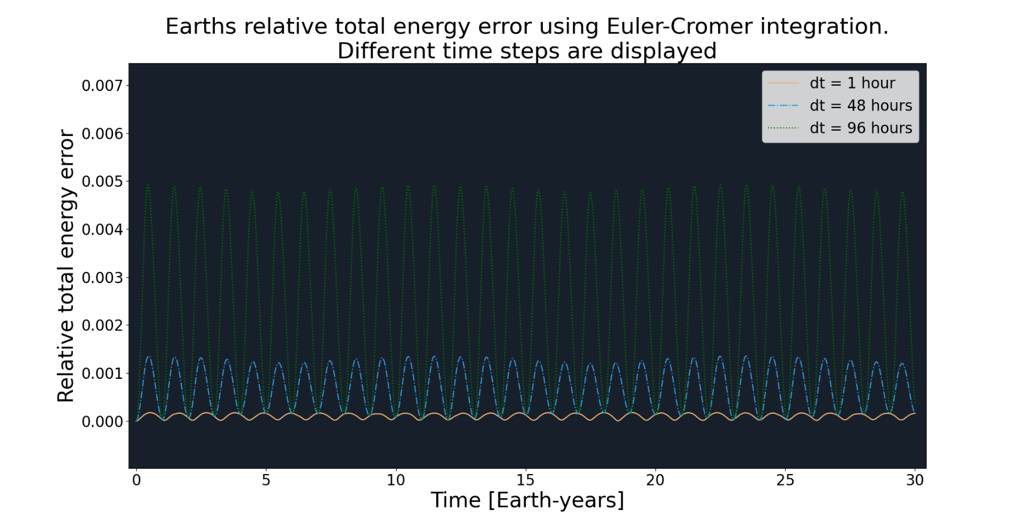Figure 4.4 – 2: Total relative energy error of Earth using Euler-Cromer integration. Note that the error is limited to a half percent using these time-steps*

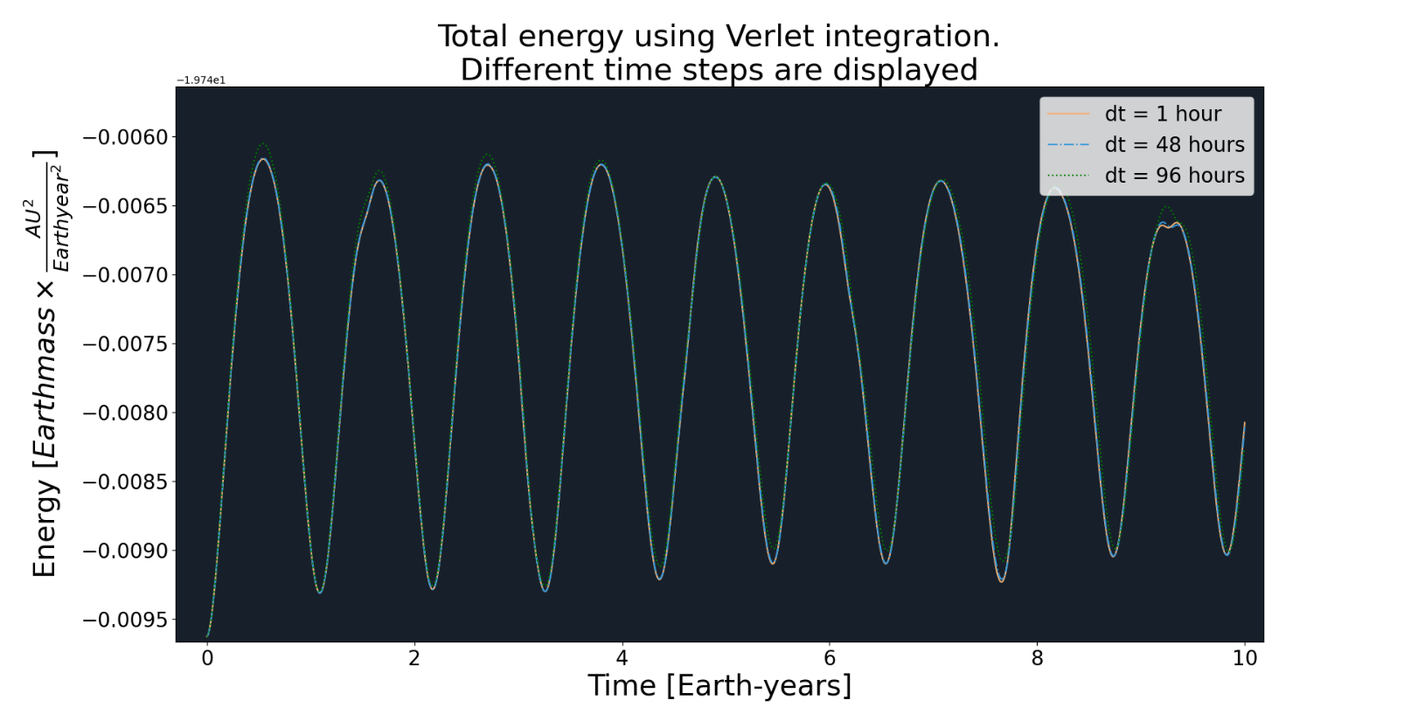

*Figure 4.4 – 3: Total energy developing of earth using Verlet integration. Verlet yields better results in conserving total energy. Note that the graphs are stacked on each other.*

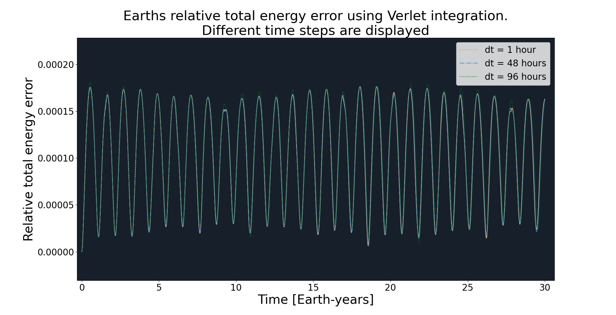 *Figure 4.4 – 4: Total relative energy error of Earth using Verlet integration. Note that the error is limited to a fiftieth of a percent using these time-steps. This result suggests Verlet conserves energy better than Euler-Cromer. Note that the graphs are stacked on each other.*

## Asteroid perturbance to Earth’s orbit

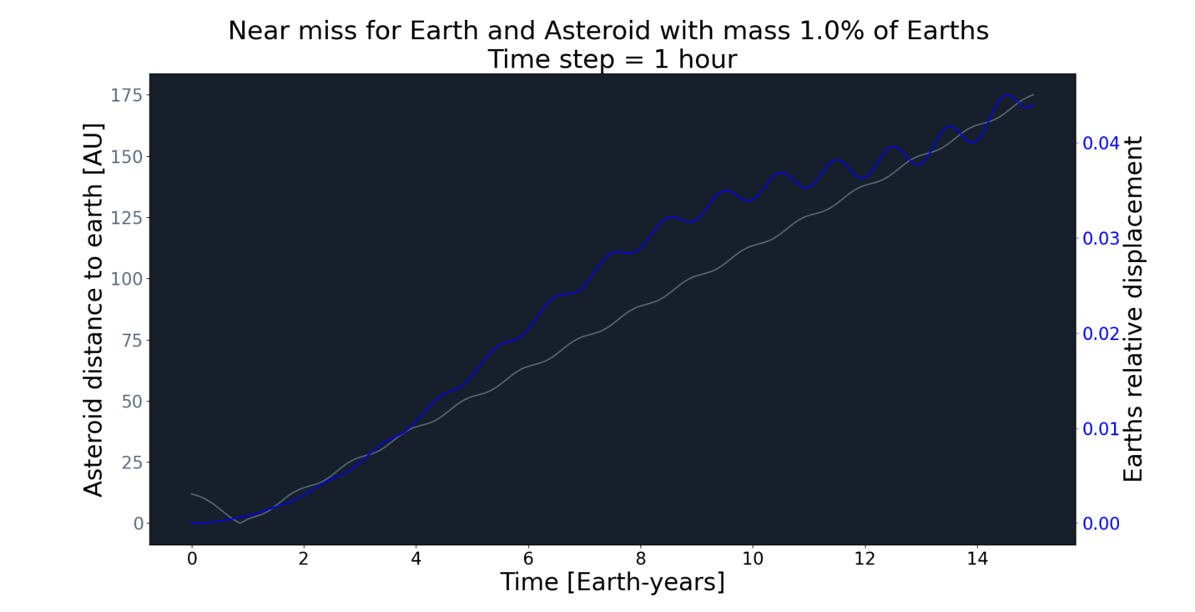When assessing threats, one natural desire is to quantify the change of Earth’s orbit in an event of near collision with an asteroid. If earth were to be flung out of orbit there is a risk that Earth exists the Goldilocks Zone, the habitable distance, which would be a death sentence to humanity as of today. In this section a large asteroid, with 1% of Earths mass and an enormous planet sized asteroid with mass 100 times that of Earths mass will be simulated in a near collision.

*Figure 4.5 – 1: Earths relative displacement (blue) and asteroid distance to earth (gray) plotted as a function of time. Near miss happens after roughly 1 year.*

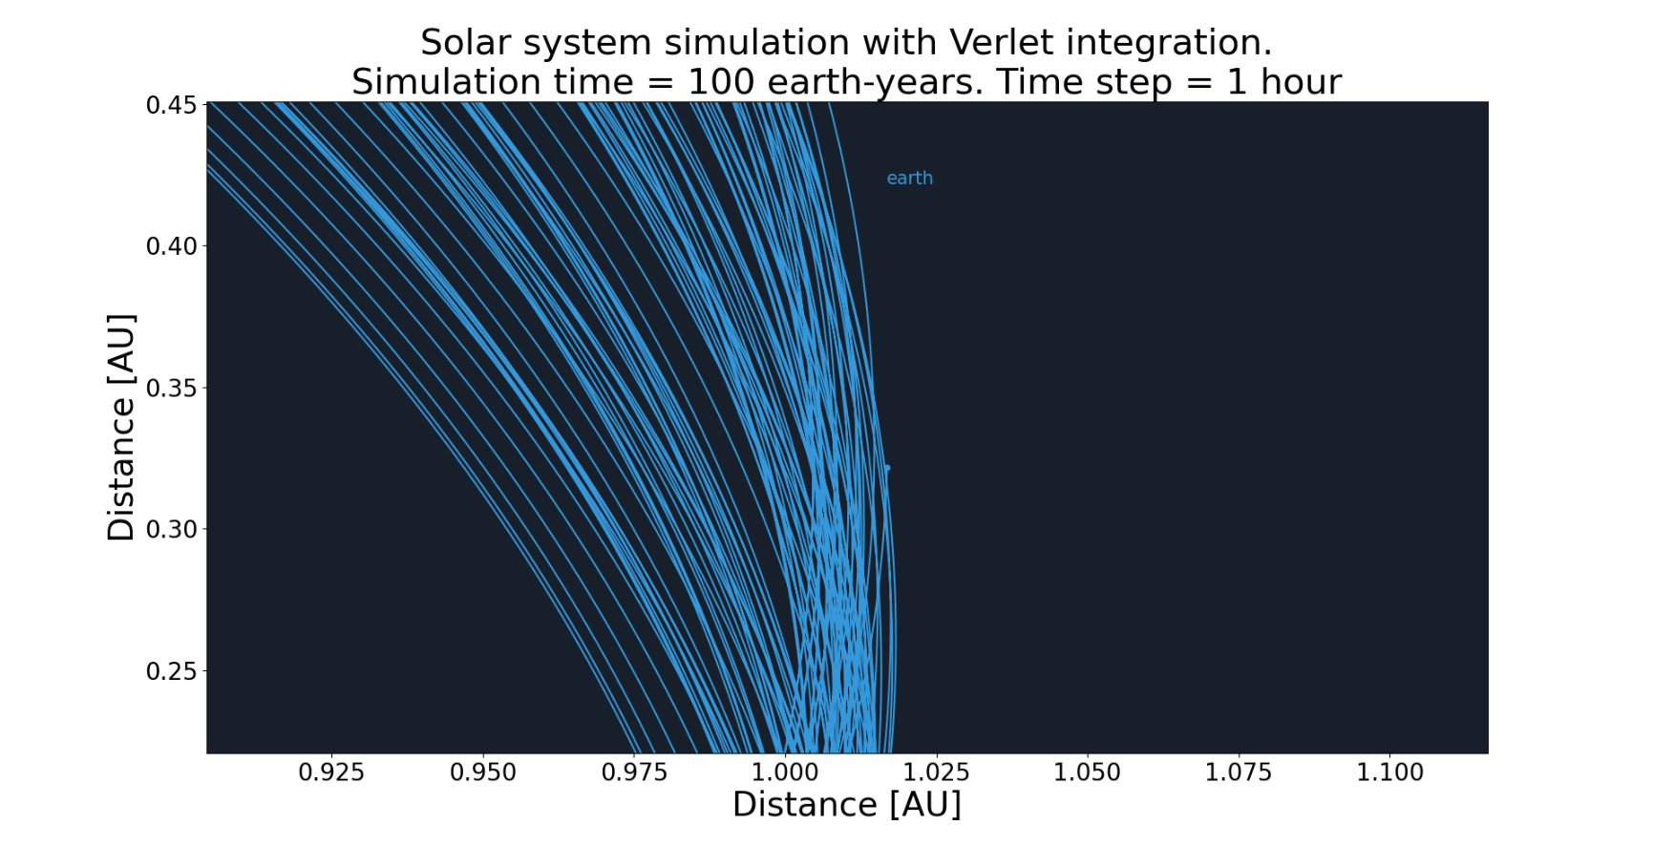*Figure 4. 5 – 2: Visualisation of earth still in orbit after near miss with asteroid from figure 4.5-1.*

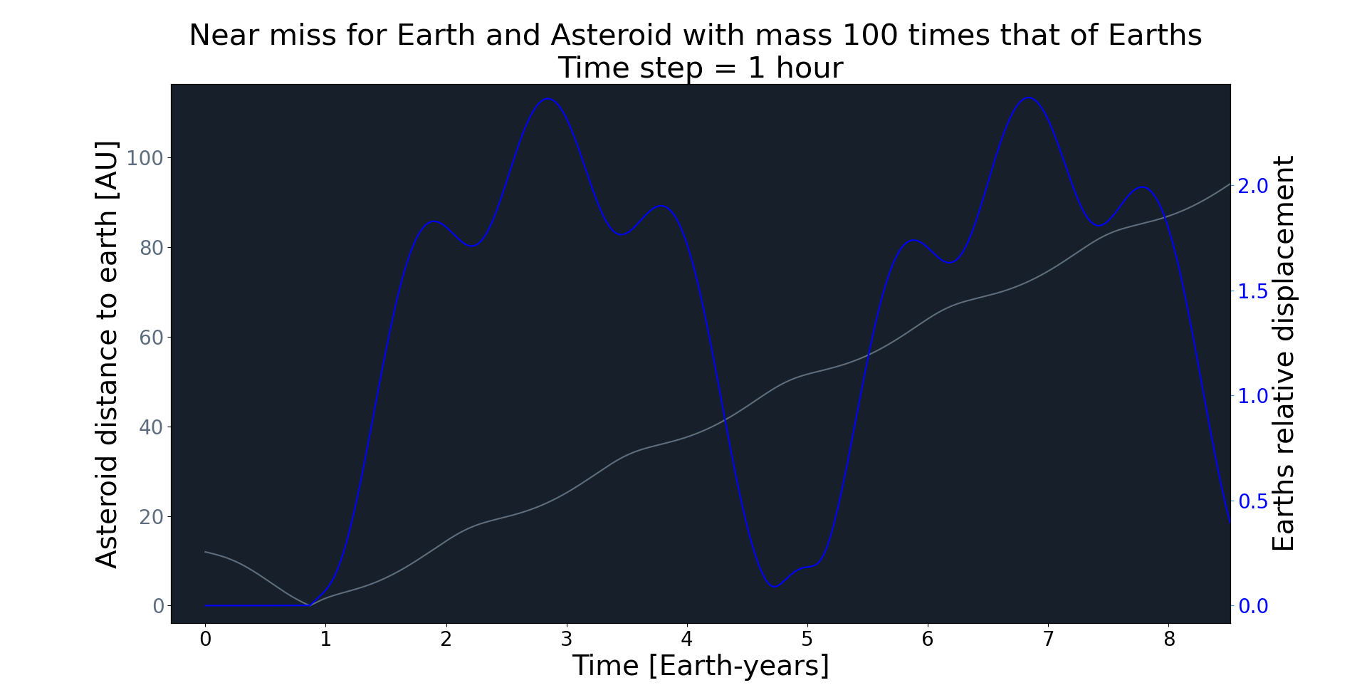

*4.5 – 3: Earths relative displacement (blue) and asteroid distance to earth (gray) plotted as a function of time. Near miss happens after roughly 1 year. Earth is ejected out of its normal orbit.*

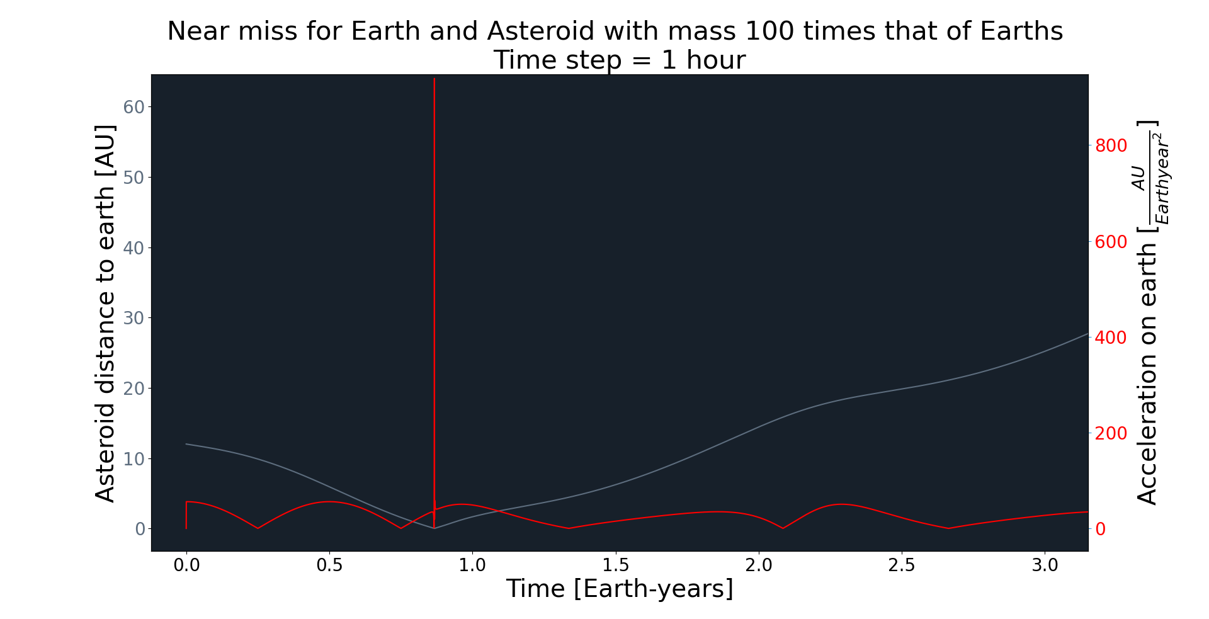*4.5 – 4: Earths acceleration (red) and asteroid distance to earth (gray) plotted as a function of time. Near miss happens after roughly 1 year. The acceleration on Earth when asteroid is close skyrockets.*

*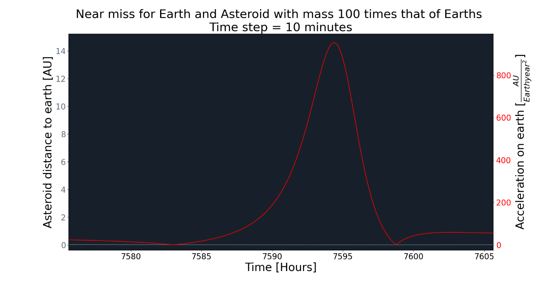4.5 – 5: Earths acceleration (red) and asteroid distance to earth (gray) plotted as a function of time. This figure is a zoomed version of 4.5 – 4. The acceleration on Earth when asteroid is close skyrockets under the duration of roughly 10 hours.*

# Discussion

* 1. The effects of an asteroid passing close to earth

The results of figure 4.5-1 shows that if an asteroid of large but not abnormal mass (roughly around 1% of Earth’s mass) comes close, our trajectory will be perturbed - but not by much (see figure 4.5-2). However, if an asteroid 100 times the mass of earth were to pass close, the relative error of Earth’s orbit will change significantly. Figure 4.5-3 suggests that after roughly 3 years of time the Earth is misplaced by over 2 astronomical units. In figure 4.3.2-1 the simulation shows how detrimental an asteroid with the unrealistic mass of a star would be. Should a similar event occur one may wonder what it is that humans could possibly do.

It is clear that a super-massive object could completely thwart the solar system balance, however, a more practical question might be what the actual risks are. This question is highly relevant but is outside the scope of this report. Further research needs to be conducted to say anything about the actual dangers Earth face.

## Quality of integrators

The results in section 4.4. shows that both Euler-Cromer integration scheme and Verlet integration scheme are great integrators when simulating conservative forces within the solar system. As seen in figure 4.4-2 and 4.4-4, both symplectic integrators limit the relative error of Earth’s orbit. In fact, the error of both integrators is periodic which holds true even for longer time steps, albeit Euler-Cromer becomes noticeably less accurate with longer time steps.

Figure 4.4-4 shows Verlet integrator limits the relative error to under a fiftieth percent without dropping accuracy with the chosen coarser time-steps. Figure 4.4-2 shows Euler-Cromer integrator losing accuracy with coarser time-steps, which implies Verlet integrator is preferred for more accurate simulations. The Verlet integrator have a local error in position limited by fourth order time steps explaining why Verlet integrator surpasses Euler-Cromer integrator which has a local error in position limited by second order time steps.

One may be more adamant for speed of simulation rather than accuracy. This report does not analyse or consider time complexity of the two integrators. In conclusion, for simulating the solar system with maximum accuracy, the results in this report suggest Verlet integrator is preferable over the Euler-Cromer integrator

# On chaotic motion

It is clear from figure 4.3.2-2 and 4.5-5 that if masses and accelerations are great enough the equilibrium can quickly change. This quick change allows for chaotic motion because if the integrator is too slow (step size too large) the information of the change in acceleration can easily be missed. A great simulation needs to address sudden changes to mitigate chaotic effects. An integrator with adaptive step size is an alternative to the symplectic integrators used in this report. These have not been used to ease the implementation and preserve the system energy as best possible.

# References

[1]: [https://en.wikipedia.org/wiki/Sun](https://en.wikipedia.org/wiki/Sun%20)

[2]: <https://en.wikipedia.org/wiki/Hamiltonian_mechanics>

[3]: <http://www.macs.hw.ac.uk/~simonm/mechanics.pdf> sida 49